Electric Bill

Tittle: To calculate Electric bill
Topics: Range, In between, Integer, float, input functions, variables
Problem Statement:
To design and implement a program that calculate the electricity bill based on the number of units consumed using slab-wise traffic rates and fixed service charges ensuring accurate and automated billing
Roles& Responsibilities:
- Project Manager:
  - Team coordination
  - Final project to delivery client
- Backend Developer:
  - Billing logical implement
  - Correct output to generate
- Frontend Developer:
  - To create a form entering units
  - To display output
- Tester:
  - Identifying bugs
  - To check the bill calculate
Code:
- Using range :
def calculate_bill(units):
minimum_price = 200 # Minimum charge for first 50 units
service_charge = 50 # Fixed service charge
bill = 0

if units in range(0, 51): # 0–50 units
bill = minimum_price

elif units in range(51, 101): # 51–100 units
bill = minimum_price + (units - 50) * 5

elif units in range(101, 201): # 101–200 units
bill = minimum_price + (50 * 5) + (units - 100) * 8

elif units in range(201, 301): # 201–300 units
bill = minimum_price + (50 * 5) + (100 * 8) + (units - 200) * 3

else: # Above 300 units
bill = (
minimum_price +
(50 * 5) +
(100 * 8) +
(100 * 3) +
(units - 300) * 22
)

return bill + service_charge

# -------- DECLARED VARIABLE (NO INPUT) --------
units = 120 # you can change this value
amount = calculate_bill(units)

print("Units:", units)
print("Your bill:", amount)
- Using In between:
def calculate_bill(units):
service_charge = 50
bill = 0

if 0 <= units <= 50:
bill = 200
elif units <= 100:
bill = 50 * 5 + (units - 50) * 5
elif units <= 200:
bill = (50 * 5) + (50 * 5) + (units - 100) * 8
elif units <= 300:
bill = (50 * 5) + (50 * 5) + (100 * 8) + (units - 200) * 13
else:
bill = (50 * 5) + (50 * 5) + (100 * 8) + (100 * 13) + (units - 300) * 22

return bill + service_charge

units = float(input("Enter units: "))
amount = calculate_bill(units)
print("Your bill:", amount)
- Using Variables(Int):
def calculate_bill(units):
service_charge = 50
bill = 0

if 0 <= units <= 50:
bill = 200 # minimum price

elif 51 <= units <= 100:
bill = 50 * 5 + (units - 50) * 5

elif 101 <= units <= 200:
bill = (50 * 5) + (50 * 5) + (units - 100) * 8

elif 201 <= units <= 300:
bill = (50 * 5) + (50 * 5) + (100 * 8) + (units - 200) * 13

else:
bill = (50 * 5) + (50 * 5) + (100 * 8) + (100 * 13) + (units - 300) * 22

return bill + service_charge

# using int variable
units = int(input("Enter your units: "))

amount = calculate_bill(units)
print("Your bill:", amount)
- Using float (variable):
def calculate_bill(units):
minimum_price = 200
service_charge = 50

if 0 <= units <= 50:
bill = minimum_price

elif units <= 100:
bill = minimum_price + (units - 50) * 5

elif units <= 200:
bill = minimum_price + (50 * 5) + (units - 100) * 8

elif units <= 300:
bill = minimum_price + (50 * 5) + (100 * 8) + (units - 200) * 3

else:
bill = (
minimum_price +
(50 * 5) +
(100 * 8) +
(100 * 3) +
(units - 300) * 22
)

return bill + service_charge

# -------- INPUT & OUTPUT --------
units = int(float(input("Enter your units: "))) # ⭐ main logic
amount = calculate_bill(units)

print("Units:", units)
print("Your bill:", amount)
Output :
- Using Range:
  - Units:250
  - Your bill:2000

- Using in between:
  - Units:250
  - Your bill:2000
- Using variable(int):
  - Units :200
  - Your bill:1300
- Using float:
  - Units:120.5
  - Your bill:660
Image:
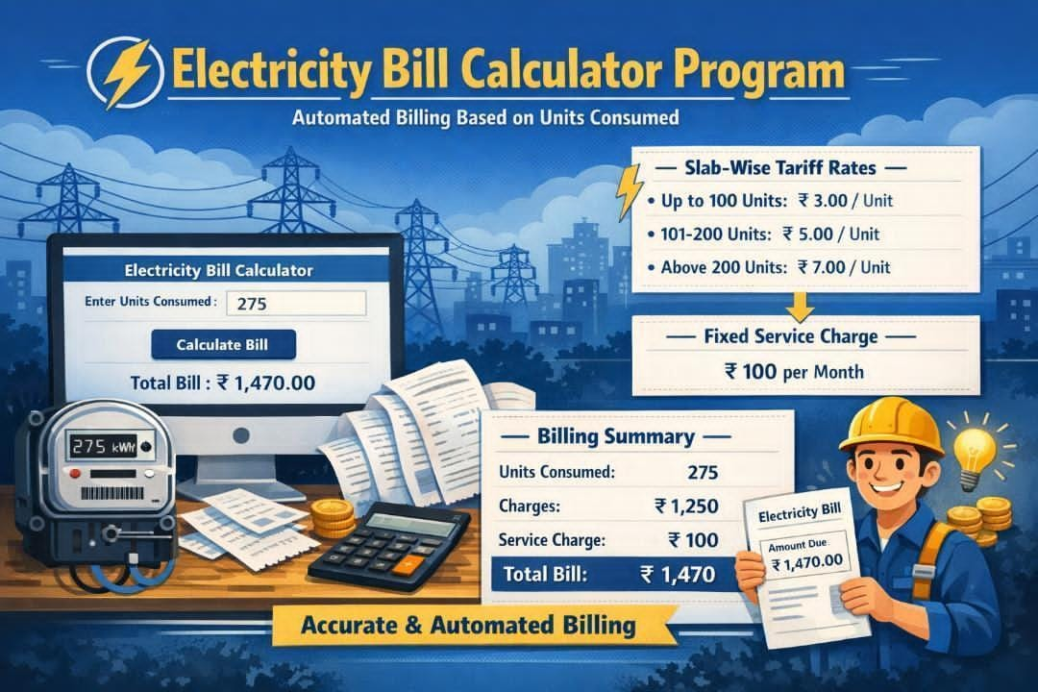

Interview Questions:
- What is the aim of the project
  - Automation
- What does the program calculate
  - Electricity bill
- What is the input/output of the program
  - Units/amount
- Which logic is used for calculate
  - Slab
- Which programming concept is mainly used
  - Conditional Statements
- Why are function used
  - Reusability
- What is the main advantages of this system
  - Efficiency/Time Consumption

